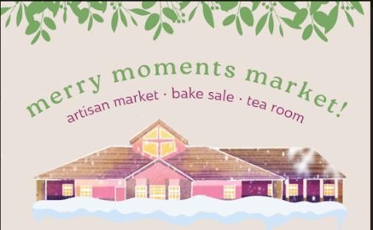
Merry Moments Market
November 28, 2026; 10:00 am – 3:00 pm Southminster-Steinhauer United Church 10740-19 Ave NW Edmonton AB
We are delighted to invite you to participate in the
4th Annual Merry Moments Market
We have thirty spaces available for Artisans. Each space is approximately 8’ x 6’ with one 6-foot table and two chairs and the area will be full of Christmas ambiance and live piano music and carolers. You will have access to WIFI, space for a break/lunch and a secure area for your coats/extra boxes if needed.
Artisan/vendors will create, bring and sell your product. You will supply your own table covering, and payment options for your customers. If you choose to, you may use your own table/ marketing display. You are 100% expected to promote your presence and your product on social media – and we will also do this for you with our channels.
Merry Moments Market is a juried selection, so be sure that your submitted pictures are a true representation of your product.
- Applications and pictures can be emailed, and we request a post-dated cheque mailed to us as a deposit. Pictures can be emailed or mailed if you prefer.
Once your application has been accepted, then your table fee of $60.00 must be received 5-7 days. (Your cheque must be dated October 31, 2026 and made out to Southminster Steinhauer United Church with Merry Moments Market on the subject line. EFTs by special request only.

- Please mail to:
Erin Robinson – 2045 Hilliard Place NW, Edmonton, AB T6R3P5
Submissions being accepted until August 30, 2026.
- Set up is from 4-7 pm Friday, November 27 and 8am-9:45 am November 28 - Market Day. All booths must be ready to go at 10 am and packing up will start at 3 pm only. Late arrivals will not be admitted nor refunded.

- Parking will be available for you in a designated area, away from the door.


Merry Moments Market Application November 28, 2026 at Southminster-Steinhauer United Church
NAME:
ADDRESS: CITY:
POSTAL CODE:
TELEPHONE: (daytime) EMAIL: (required)
DESCRIPTION OF PRODUCT: _____________________________________________________________
_________________________________________________________________________________________
PRICE RANGE:
INSTAGRAM/FACEBOOK link:
Do you need an outlet? Yes/ No Bringing your own table? Yes/No Do you need a table? Yes/ No Do you require wall space? Yes/ No
Please note that Vendor insurance is encouraged and can be obtained here: https://duuo.ca/vendor- insurance/
Also note that Southminster-Steinhauer is under no circumstances liable for damage or loss to you or your product while on the premises for the event.
Merry Moments Market will run from 10am to 3pm. Set-up is either the evening of November 27 from 4pm to 7pm or the morning of November 28 from 8am to 9:45am. All tables must be ready to open at 10am.
There will be no late admittance. Please remember that your booth should not be packed up until after 3pm.
PHOTOS: We will be requiring photos or reels of your crafts/product to display on our website for shoppers to view. Remember to show your items at their very best! Please submit to: mmm@ssucedmonton.ca
Every applicant must provide current photos to be considered.
Please mail to applications to: Erin Robinson – 2045 Hilliard Place NW, Edmonton, AB T6R3P5
Refunds will not be issued for cancellation by artisan after September 1, 2026, unless we can fill the space. If for any reason WE must cancel, you will be refunded in full.
Cheques must be dated Oct 31, 2026 and be made payable to Southminster-Steinhauer United Church with “Merry Moments Market” on the memo line. Applications should be received by August 30, 2025.
Vendors will be notified by email September 30, 2026 or earlier.

Parking for vendors

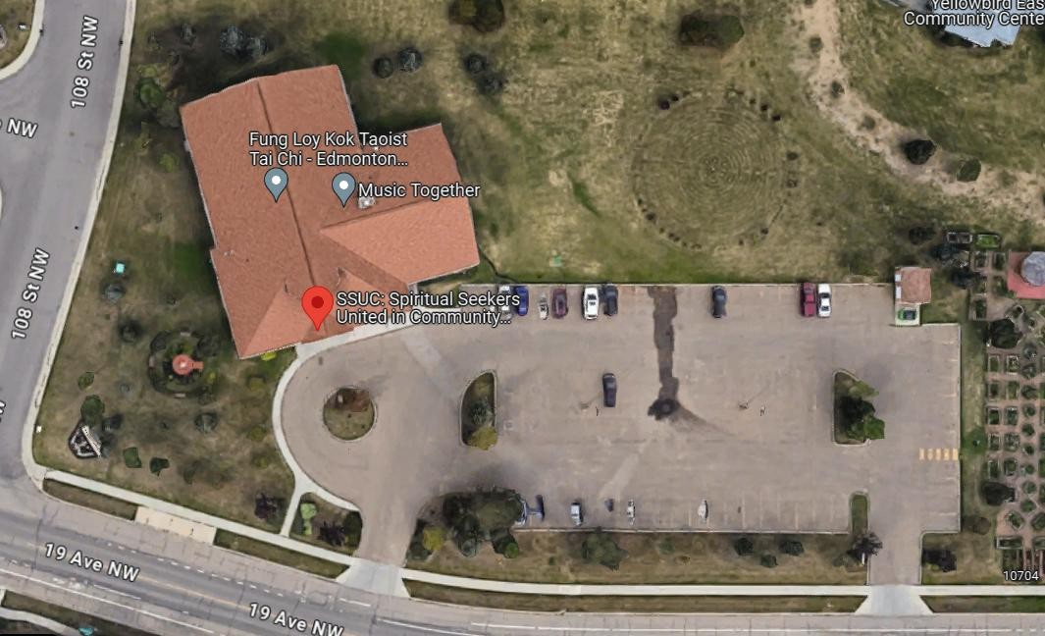
Please know that Southminster-Steinhauer United Church is a signatory on the Earth Charter and is an Affirming Church within the United Church of Canada. As such, we honour our natural environment and welcome all people.
Parking for vendors
Southminster-Steinhauer is a community where a diverse community of people gather to explore the best of their humanity and how that might inspire us to live with each other, with nature and the world. Southminster-Steinhauer is anything but ordinary: committed to celebrating and exploring truth, passion, justice and courageous living, the community holds a reverence for spiritual life.

